[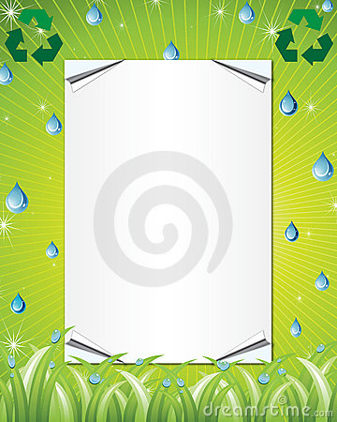](http://www.google.co.uk/url?sa=i&rct=j&q=&esrc=s&frm=1&source=images&cd=&cad=rja&uact=8&ved=0CAcQjRw&url=http://es.dreamstime.com/imagenes-de-archivo-blindaje-de-eco-image28614174&ei=G3XwVMvQFYve7AbmxIGIDA&bvm=bv.87269000,d.ZGU&psig=AFQjCNG5WGPzehIIgf5lfq3QK0wDt2VbOQ&ust=1425131136697166)

**Our Eco Code.**

At *St Teresa’s Primary School* we **recycle**

paper, plastic and bottles too!

We make compost in the bin,

with apples, oranges and banana skins!

Compost is cool, it’s made from fruit

Use it to plant and don’t pollute.

We **reduce** waste, help our planet,

Feed the birds and do not panic.

We **reuse** containers for our lunch,

just like I do with mine,

we reuse all the time,

We really are a happy bunch.

Turn off the lights when you go away

or outside to play.

Pick up the Litter, don’t be Bitter!

Keep Our Planet clean,

Come on everyone, Let’s BE Green!